|  |
| --- |
| **TERI Partner Network: Developing a Shared Culture of Evidence** |

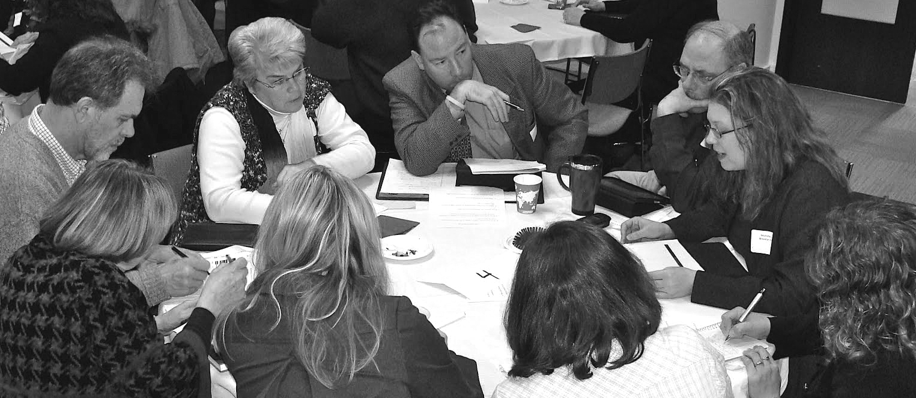

April 26, 2012

Urban Research and Outreach–Engagement Center (UROC)

2001 Plymouth Avenue North  
Minneapolis, MN

**Goals for our day together**

* Continue to build the TERI Partner Network (University of Minnesota teacher education programs and partner school districts) with the shared goal of increasing academic achievement of all P-12 students
* Jointly create a shared culture of evidence in our teaching and ongoing program improvement practices across the TERI Partner Network
* Identify available data sources that can inform ongoing improvement in practice, curriculum, and program development
* Practice using data to identify opportunities for improvement

**Agenda**

|  |  |
| --- | --- |
| 8:30 – 9:00 | Breakfast and Networking |
| 9:00 – 9:15 | Welcome and Framing of the Day  *Misty Sato, TERI Director* |
| 9:15 – 10:00 | Using Data to Improve Student Learning: An Example from Practice  *David Heistad, Minneapolis Public Schools* |
| 10:00 – 10:15 | Message from CEHD Dean  *Dean Jean Quam* |
| 10:15 – 10:30 | Break |
| 10:30 – 11:30 | Using Data to Drive Teacher Preparation Program Improvement: Current Research Studies  Developing Equity-minded Teachers of Diverse Students: CEHD's Teacher Identity Self Study  *Annie Mason & Fang Wang*  More Than Someone Who Watches: The Essentials of Supervisor Feedback  *Jessica Winkelaar & Hallie Kamesch*  From Establishing University-School Partnerships to Building Relationships  *Shannon McManimon*  The Other Teacher Educators: Cooperative Teachers' Perspectives on Co-Teaching and Teacher Educator In-Between: A Self-Study  *Jehanne Beaton* |
| 11:30 – 12:15 | Using Data for School Improvement: Understanding Value Added Measures  *Kaveh Akram , Value Added Research Center*  *David Heistad, Value Added Research Center*  *Marian McClellan, Center for Data Quality and Systems Innovation*  *Mikhail Pyatigorsky, Value Added Research Center*  *Yan Wang, Value Added Research Center*  *Jeff Watson, Value Added Research Center* |
| 12:15 – 1:00 | Lunch |
| 1:00 – 1:45 | Using Data for School Improvement: Examining School Data in Small Groups  *VARC Team* |
| 1:45 – 2:15 | Using Data in the Classroom: Spencer Foundation Request for Proposals for Investigating Whether, When, and How Student Performance Data Inform Instruction  *Misty Sato, TERI Director* |
| 2:15 – 2:30 | Dessert Break |
| 2:30 – 3:30 | Using Data to Improve Teacher Candidate Recruitment: Everyone is a Recruiter  *Arien Telles, TERI Coordinator of Recruitment and Retention* |
| 3:30 – 3:45 | Wrap Up and Feedback |