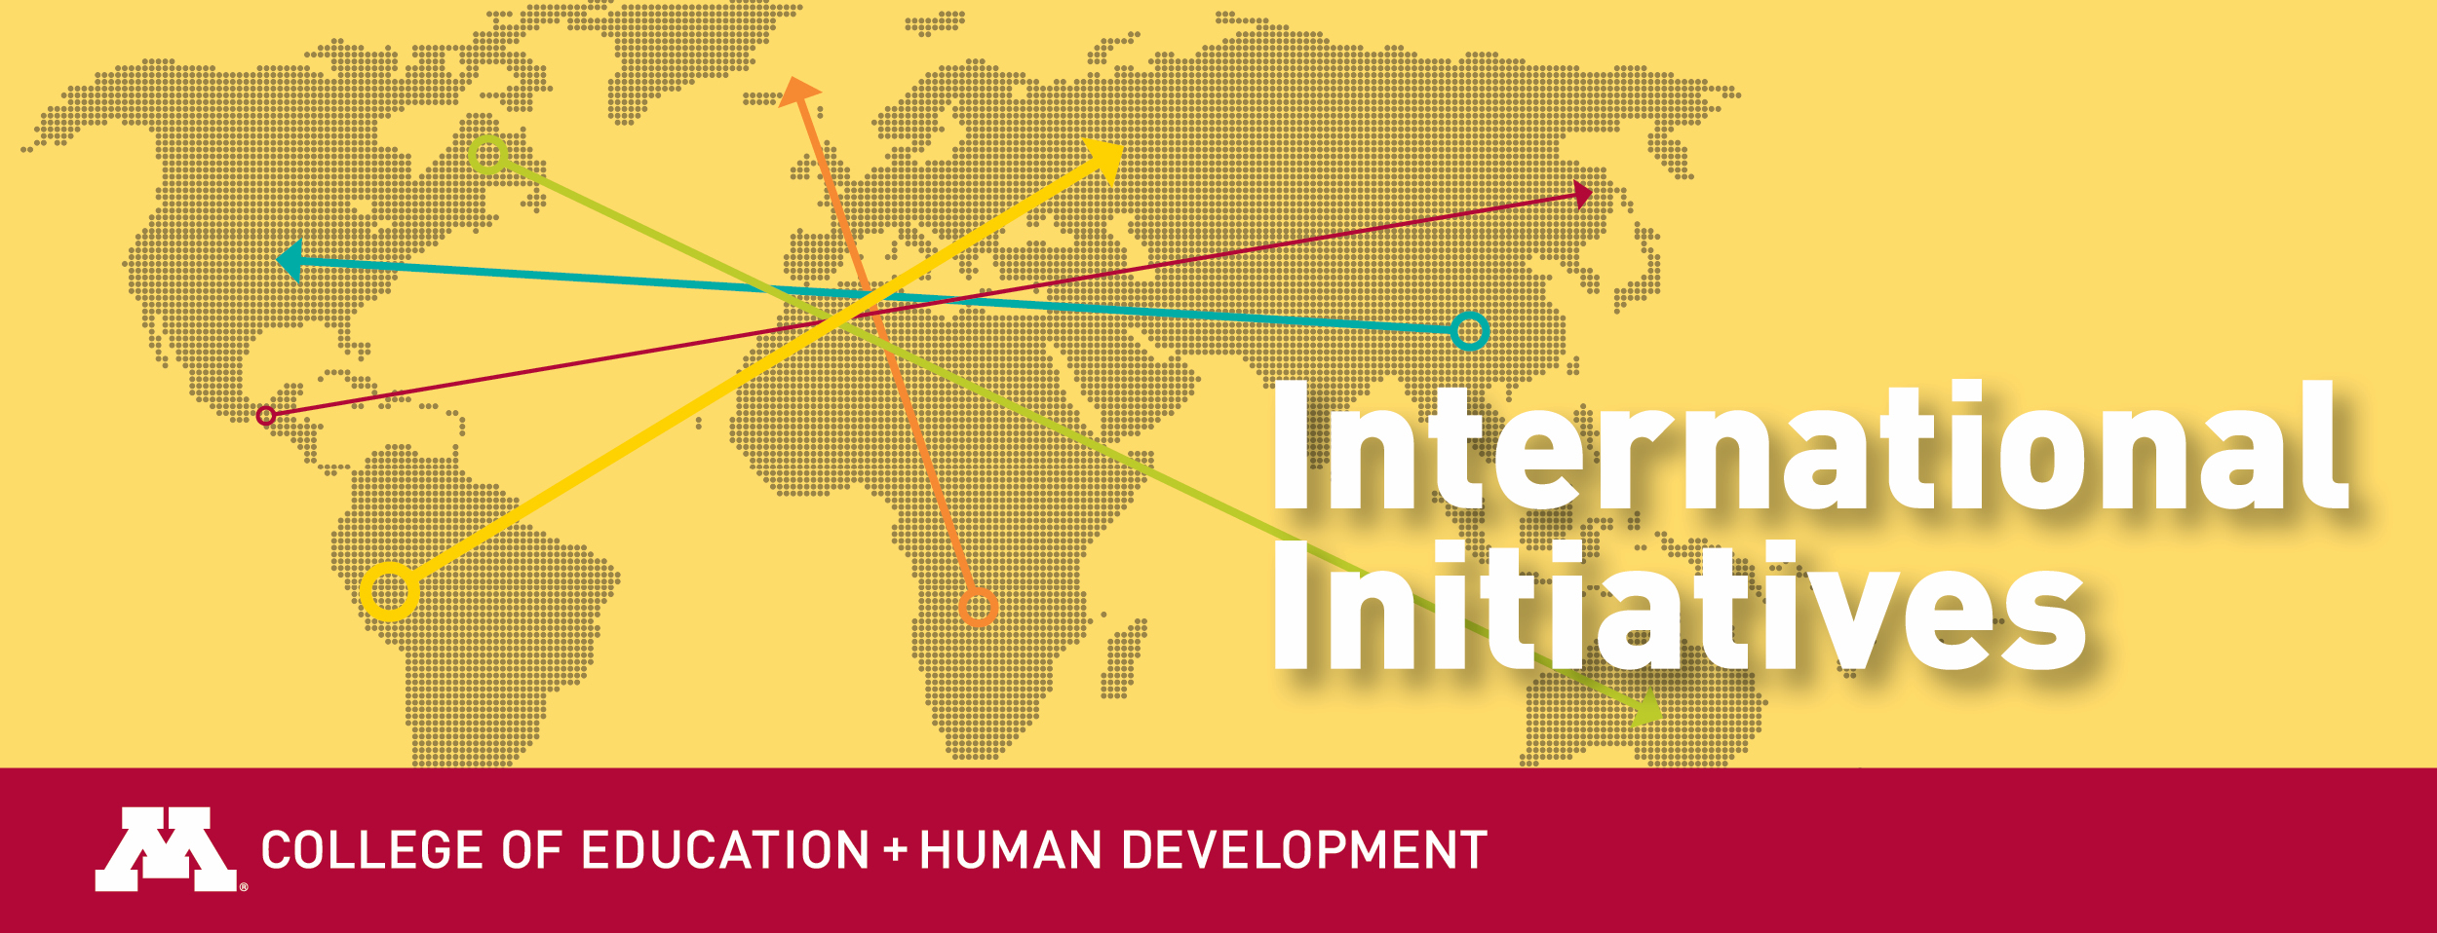

CEHD Global Signature Grants – Call for Proposals 2020-2021

Overview: The CEHD Global Signature Grant is awarded to a faculty, P&A staff, department, or center that proposes program initiatives that demonstrate the college’s commitment to global engagement. Individual or group projects are considered, with priority given to projects that are interdisciplinary. CEHD Global Signature Grant projects are exemplars of institutionalized internationalization and global commitments in CEHD. They demonstrate our college’s strength through globally-focused, mission-driven activities.

Purpose: The purpose of this grant program is to support the creation of an institutional culture of global engagement in CEHD. By supporting projects in this process, we seek to institutionalize our global focus, creating opportunities to integrate chosen activities into their core functions and support projects that need extra funding to begin, continue, or complete their activities. Projects that are interdisciplinary and integrate individuals from multiple centers or departments may have higher potential for sustainability than those that depend on individuals, therefore these would be given priority. We consider interdisciplinary to be both within the college or with partners outside the college. For the purpose of this grant attending an international conference is not considered an eligible project.

Global Signature Grant Programs include, but are not limited to:

- Research abroad opportunities and collaboration
- International engagement activities (e.g., delivery of workshops, training, or seminars), particularly to low income countries (as classified by the World Bank)
- Global social justice-orientated programs
- Glocal programs (those that are locally based with global components)
- Developing academic curricula with global content
- Visiting scholar activities or programs

Grants Program Timeline: Up to 4 grants will be supported for implementation of activities from May 2020 through August 2021.

Support includes:

- Meetings with CEHD International Initiatives staff with the intent of connecting relevant program needs to college and university-wide or external resources.
- Up to $10,000 support for travel, external consultant fees, research related expenses, or other relevant program needs. Funding cannot be used to support graduate assistant time.
- Other supports on an as-needed basis

Application Procedure:

- Interested individuals, departments, or centers should submit a 1000-word proposal by February 3rd, 2020 including:
  - Overview of the program
  - Implementation timeline with aims to launch in the year awarded
  - Contribution of program to broader global efforts in CEHD
  - Budget
  - Letter of support from Department Chair or Center Director. For group applications one department chair letter is sufficient, with evidence of other department chair approval.
  - CVs from key implementers

Applications are due at 5PM on February 3rd, 2020 to Marina Aleixo, aleix001@umn.edu.

Review Process: CEHD Global Signature Grants are reviewed by a selected committee of 5-7 individuals, including past award recipients. Announcements of awards will be made by end of February 2020.

Additional Information:

- Individuals, departments, or centers can appear in more than one application for different programs.
- Projects funded in 2019-2020 may not be re-funded, however projects funded in previous years are eligible for continued support.
- Please direct all questions to Marina Aleixo, aleix001@umn.edu

